PRDA – 1 Profit Analysis

Startup Profit Prediction Analysis Using
Multiple Linear Regression
PRABU R
Datamites Internship
27 May 2026

Introduction

Startup profitability depends on several financial factors such as Research and Development (R&D) expenditure, Administration costs, and Marketing spend.
This project aims to analyze startup investment patterns and predict profit using Multiple Linear Regression.
Power BI is used to create an interactive dashboard for better visualization and business decision-making.

Problem Statement

Startups need to understand how different investment areas affect profitability.
Without proper analysis, organizations may allocate resources inefficiently.
This project helps identify key spending factors influencing profit and predicts future profitability.

Objectives

- To analyze startup expenditure data
- To identify factors affecting profit
- To predict startup profit using regression analysis
- To compare state-wise performance
- To generate business recommendations

Dataset Understanding

The dataset contains startup financial information.
Input Features (Independent Variables)
- R&D Spend
- Administration Spend
- Marketing Spend
- State
Target Variable (Dependent Variable)
- Profit
The dataset is used to understand the relationship between investments and profitability.

Data Preprocessing
The following preprocessing steps were performed:
1. Missing Value Check
The dataset was checked for missing values.
No significant missing values were found.
2. Data Cleaning
The dataset was verified for consistency and duplicate records.
3. Categorical Variable Handling
The State column was retained for separate state-wise comparative analysis in dashboard visualizations
4. New Columns Created
The following calculated columns were added:
- Predicted Profit
- Residual Error
- Category
These columns help evaluate prediction accuracy.

Regression Analysis

Model Used
Multiple Linear Regression
Regression Formula for Predicted Profit
Predicted Profit = β₀ + β₁(R&D Spend) + β₂(Administration Spend) + β₃(Marketing Spend)
Where:
- β₀ = Intercept
- β₁, β₂, β₃ = Regression coefficients

Regression Interpretation

The regression model shows how each financial factor influences profit
Key Interpretation
- Higher R&D spend positively impacts profit
- Marketing spend contributes to profitability
- Administration spend has moderate impact
- State affects overall startup performance
The model predicts profit with reasonable accuracy.

Excel Regression Output
Excel regression analysis was performed using Data Analysis ToolPak.
The output includes:
- Regression Statistics
- R Square Value
- ANOVA Table
- Coefficient Values
These outputs validate the regression model.

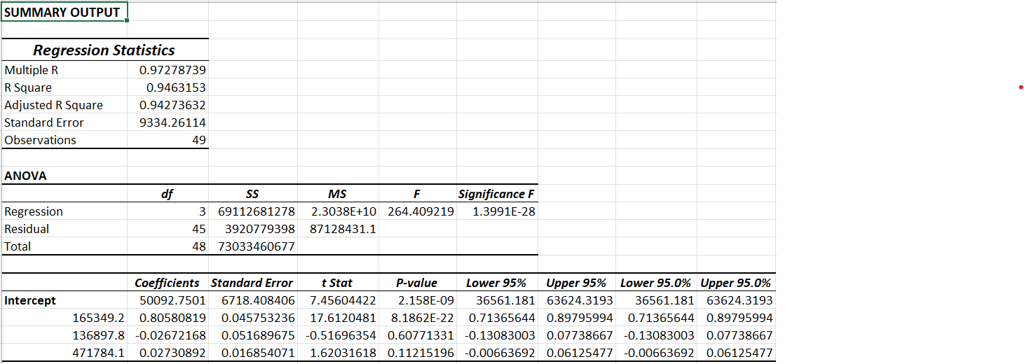
Power BI Dashboard Analysis
The dashboard was developed using Power BI.
Dashboard Components
- Total Profit KPI
- Predicted Profit KPI
- Profit by State
- Average Residual Error by State
- Spending Analysis
The dashboard provides interactive insights.

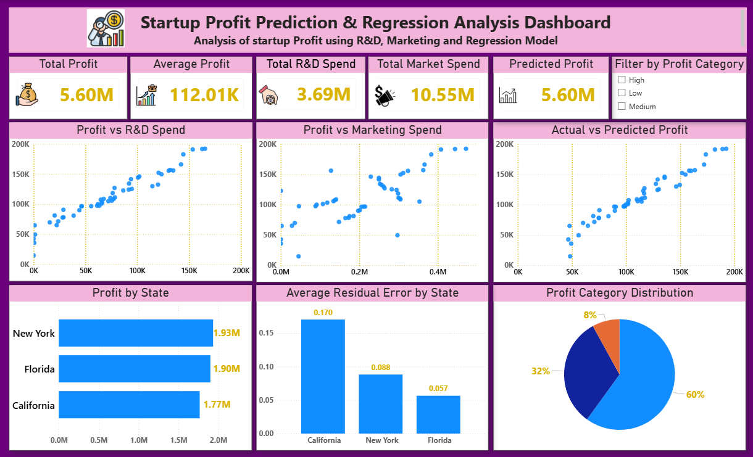
Key Insights

The analysis produced the following insights:

- Higher R&D spending leads to better profit performance.
- Marketing expenditure positively influences growth.
- Profit performance varies across different states.
- Predicted profit closely matches actual profit indicating good model accuracy
- Residual error analysis helps evaluate prediction accuracy.

Business Recommendations

Based on the analysis:

- Increase investment in R&D.
- Optimize marketing budget allocation.
- Focus expansion strategies on profitable states.
- Regularly monitor prediction deviations.

Conclusion

This project successfully predicted startup profit using Multiple Linear Regression.
The Power BI dashboard effectively visualizes business performance and provides actionable insights.
The analysis supports better financial planning and strategic decision-making.

Tools Used

- Microsoft Excel
- Power BI
- Regression Analysis ToolPak

